BUAN 6320 - Database Foundations for Business Analytics

Complete Progress Report Management System
Final Project - Business Plan

Group: 3

Members:
- Sri Harsha Vardhan Koduri ( sxk210338 )
- Maheshwari Rathod (mxr210095)
- Satya Vinod Kantipudi ( sxk210365 )
- Aishwarya Ashok Mudagoudar ( axm220149 )
- Gautam Bhaskar ( gxb220005 )

Group Members Individual Contribution to the project

- Gautam Bhaskar : ( overall contribution 20% )
Business Plan
Table creation and insertion
Complex Reports – 2
Store Procedure – 3
Store Functions – 3
Trigger – 3
Views – 2
Indexes – 2
Power Point Presentation
Report Creation
- Satya Vinod Kantipudi : ( overall contribution 20% )
Business Plan
Table creation and insertion
Complex Reports – 2
Store Procedure – 3
Store Functions – 3
Trigger – 3
Views – 2
Indexes – 2
Power Point Presentation
Report Creation
- Sri Harsha Vardhan Koduri : ( overall contribution 20% )
Business Plan
Table creation and insertion
Complex Reports – 2
Store Procedure – 3
Store Functions – 3
Trigger – 3
Views – 2
Indexes – 2
Power Point Presentation
Report Creation

- Aishwarya Ashok Mudagoudar: ( overall contribution 20% )
Business Plan
Table creation and insertion
Complex Reports – 2
Store Procedure – 3
Store Functions – 3
Trigger – 3
Views – 2
Indexes – 2
Power Point Presentation
Report Creation
- Maheshwari Rathod: ( overall contribution 20% )
Business Plan
Table creation and insertion
Complex Reports – 2
Store Procedure – 3
Store Functions – 3
Trigger – 3
Views – 2
Indexes – 2
Power Point Presentation
Report Creation

Abstract

The Progress Report Management System (PRMS) project is a web application solution for universities. It was designed to help the university and its affiliated institutions to monitor, manage and analyze difficult activities such as student admission, examinations, and much more. It is a program that manages the entire student life cycle, from enrollment to graduation. Starting with the registration of a new student at the university, it keeps track of all the students' attendance and grades.

The project is concerned with information retrieval via web application. It collects information from all departments within an organization and stores it in files, which are then used to generate reports in various formats to assess students' individual and overall performance. The information is stored and retrieved by the university management system via a web-based application.

As a result, it collects data on individual and overall performance of students in various departments. PRMS focuses on the fundamental need of creating a database to accomplish the task of maintaining a large volume of information in a university. The interface is a very efficient application for university management that not only benefits university users but also plays a significant role in enabling university management to work efficiently.

Background Information:
This project is developed by five graduate students at University of Texas at Dallas under the guidance of Professor Kannan Srikanth.
We intend to be able to be able communicate accurately the status of the education progress to the students and everyone else supporting them so that they have the detailed information to make important decisions regarding the student’s education.

Project Overview:
Progress Report Management System is a cutting-edge analytics solution platform that deals in the education sector. It is a unified system that collects grading data along with student data, faculty data, and feedback data from universities which is then processed to provide insights to improve student performance and better the learning process. It also provides reports to the track and evaluate the changes made to the curriculum or learning process so that the learning needs of the students can be determined.

Proposed Method:
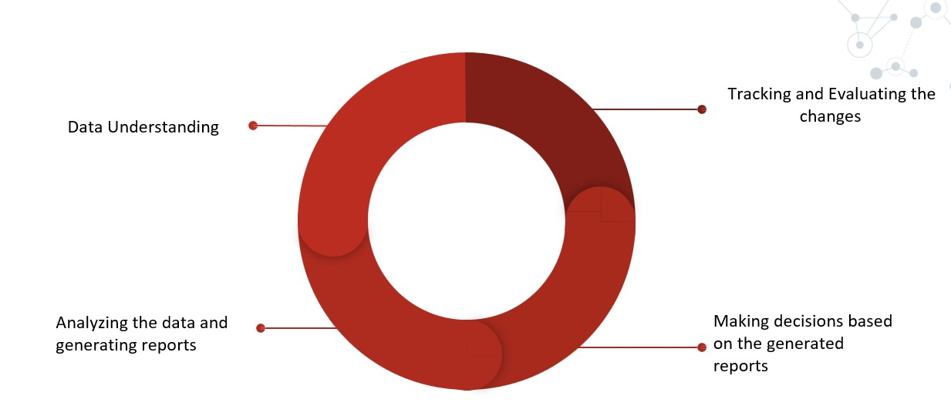

In the above figure Data Understanding comprises of gathering relevant data and performing Exploratory Data Analysis to be able better understand the attributes of all the tables. This Data is then analysed to generate reports like Grade sheet, students performing poorly, Scholarship eligibility list, faculty and course feedback.
Using these reports important decisions are made to improve the student’s education. These decisions are then tracked to evaluate the impact it had on the student’s performance. This is an iterative process, i.e, the new data is then again processed and analysed to further improve the learning process. This is done to keep with the changing circumstances especially in the education system, as no solution works forever.

Features:
- A unified system for ease of access and data integrity
- User-friendly interface
- Automated system to record grades and generate reports
- Reduces chance of errors occurring
- Faster Access to grading data
- Agile Process

Problems in the existing system:
Data storage and access in the form of Excel sheets and account books is time-consuming. It will take a lot of hard work. It frequently produces unfavorable outcomes. Keeping these records in piles may prove to be a more expensive task than any of the colleges and institutions.
The current system is time-consuming and results in inefficient results. The following are some of the risks associated with the current system: If any error is made during the entry of marks and attendance, it becomes cumulative and has adverse consequences. If you need to retrieve results, it may appear difficult to search.

Proposed Solution :
PRMS (PROGRESS REPORT MANAGEMENT SYSTEM) ensures that management always has the most up-to-date information by eliminating the need for manual accounting. It is a unified database system that stores student information, instructor information, student grades, courses enrolled, course feedback, instructor feedback and other data that is required to analyze the student progress.
We aim to develop an interactive interface that allows for easy and efficient retrieval of information without loosing data integrity.
This project intends to reduce time spent on administrative tasks. It aims to accept marks from the instructors and generate student reports, grades and transcripts accurately.
Data Required:
- Student Data
- Faculty Data
- Faculty Feedback Data
- Course Feedback Data
- Class-wise Grading Data
- Classes Data
- Subjects Data
- Majors Data
- Attendance Data
Entity Relationship Diagram :
ER Diagram stands for Entity Relationship Diagram, also known as ERD is a diagram that displays the relationship of entity sets stored in a database. In other words, ER diagrams help to explain the logical structure of databases. ER diagrams are created based on three basic concepts: entities, attributes and relationships.

ER Diagrams contain different symbols that use rectangles to represent entities, ovals to define attributes and diamond shapes to represent relationships.

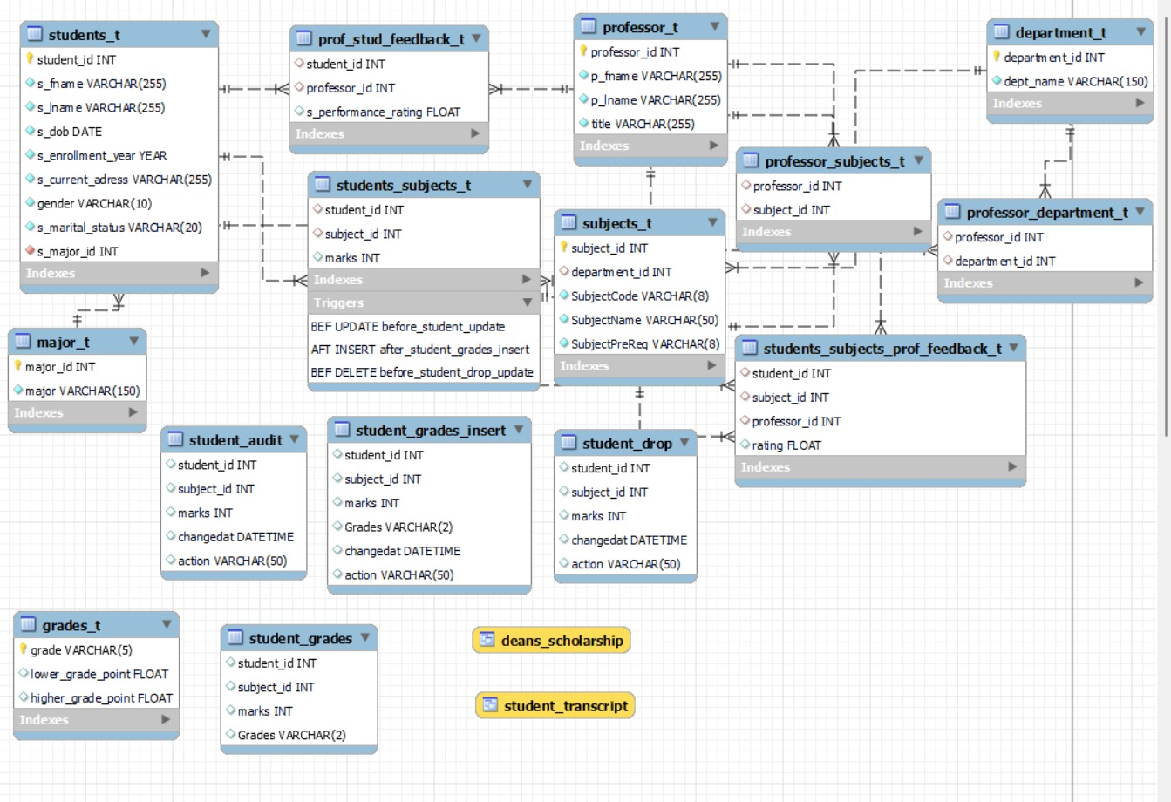

We have constructed 15 tables and two views for this project. The Created tables are
- Students_t
- Professor_t
- Subjects_t
- Department_t
- Major_t
- Grades_t
- Student_grades
- Students_subjects_t
- Professor_subjects_t
- Professor_department_t
- Prof_stud_feedback_t
- Students_subjects_prof_feedback_t
- Student_audit
- Student_grades_insert
- Student_drop

The two views are
- Deans_scholarship
- Student_transcript

Tables
Students_t :
The columns are
- Student_id(primary key)
- S_fname
- S_lname
- S_dob
- S_enrollment_year
- S_current_adress
- Gender
- S_marital_status
- S_major_id(foreign key)

Professor_t :
The columns are
- Professor_id(primary key)
- P_fname
- P_lname
- Title

Subjects_t :
The columns are
- Subject_id(primary key)
- Department_id(foreign key)
- SubjectCode
- SubjectName
- SubjectPreReq

Department_t :
The columns are
- Department_id(primary key)
- Dept_name

Major_t :
The columns are
- Major_id(primary key)
- Major

Grades_t :
The columns are
- Grade(primary key)
- Lower_grade_point
- Higher_grade_point

Student_grades :
This table is created by using case statement on students_subjects_t.
The columns are
- Student_id
- Subject_id
- Marks
- Grades

Students_subjects_t :
The columns are
- Student_id(foreign key)
- Subject_id(foreign key)
- Marks

Professor_subjects_t :
The columns are
- Professor_id(foreign key)
- Subject_id(foreign key)

Professor_department_t :
The columns are
- Professor_id(foreign key)
- Department_id(foreign key)

Prof_stud_feedback_t :
The columns are
- Student_id(foreign key)
- Professor_id(foreign key)
- S_performance_rating

Students_subjects_prof_feedback_t :
The columns are
- Student_id(foreign key)
- Subject_id(foreign key)
- Professor_id(foreign key)
- Rating

Student_audit :
The columns are
- Student_id
- Subject_id
- Marks
- Changedat
- Action

Student_grades_insert :
The columns are
- Student_id
- Subject_id
- Marks
- Grades
- Changedat
- Action

Student_drop :
The columns are
- Student_id
- Subject_id
- Marks
- Changedat
- Action

Reports Generated :
Count of Students enrolled in each subject.
Select SubjectName, count(*) as Students_Enrolled from students_subjects_t as a
join subjects_t as b
on a.subject_id=b.subject_id
group by 1
order by 2 desc;
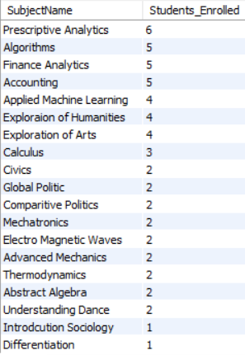

Converting Marks obtained by students to letter grades.
create table student_grades as
(Select *, case when marks between 97 and 100 then "A+"
when marks between 93 and 96.99 then "A"
when marks between 90 and 90.99 then "A-"
when marks between 87 and 89.99 then "B+"
when marks between 83 and 86.99 then "B"
when marks between 80 and 82.99 then "B-"
when marks between 77 and 79.99 then "C+"
when marks between 73 and 76.99 then "C"
when marks between 70 and 72.99 then "C-"
when marks between 67 and 69.99 then "D+"
when marks between 63 and 66.99 then "D"
when marks between 60 and 62.99 then "D-"
when marks between 0 and 59.99 then "F"
end as Grades from Students_subjects_t);
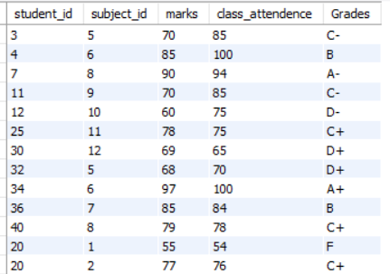

Count of data analytics’ students enrolled in the year 2020.
select count(*) from students_t
where s_enrollment_year = 2020 and s_major_id in (Select major_id from major_t where major="Data Science and Analytics");
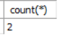

Number of Professors and Assistant Professors teaching in each department.
Select d.*,e.Asst_Professor_Count from
(select dept_name, count(a.professor_id) as Professor_Count from professor_department_t as a join department_t as b on a.department_id=b.department_id
join professor_t as c on a.professor_id=c.professor_id
where title = "Professor"
group by 1) as d
join
(select dept_name, count(a.professor_id) as Asst_Professor_Count from professor_department_t as a join department_t as b on a.department_id=b.department_id
join professor_t as c on a.professor_id=c.professor_id
where title = "Asst Professor"
group by 1) as e
on d.dept_name=e.dept_name
order by 2 desc, 3 desc;
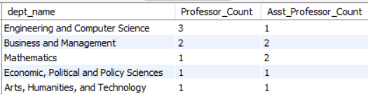

List of all affiliated members.
Select concat(s_fname," ",s_lname) as Name, "Student" as Position, major as Department from students_t as a
join major_t as b on a.s_major_id=b.major_id
union distinct
Select concat(p_fname," ",p_lname) as Name, title as Position, dept_name as Department from professor_t as a join professor_department_t as b
on a.professor_id=b.professor_id join department_t as c on b.department_id=c.department_id;
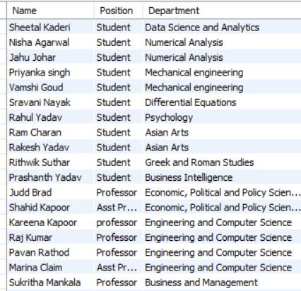

List of all the subjects and the professors teaching each subject.
select concat(pt.p_fname, " ", pt.p_lname) as faculty_name, st.SubjectName from professor_t pt
inner join professor_subjects_t pst
on pt.professor_id = pst.professor_id
inner join subjects_t st
on pst.subject_id = st.subject_id;
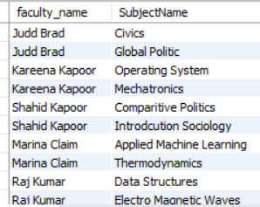

The Highest, Lowest and the average marks obtained by students in each subject.
Select SubjectName, max(marks) as Highest, min(marks) as Lowest, avg(marks) as Average from students_subjects_t as a join subjects_t as b
on a.subject_id=b.subject_id
group by 1;
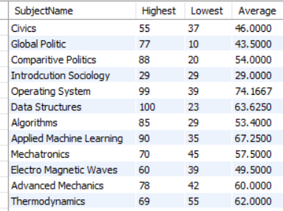

Number of students who failed in each subject.
Select SubjectName, count(student_id) as Students_grade_F from Student_grades as a join subjects_t as b
on a.subject_id=b.subject_id where Grades="F"
group by 1;
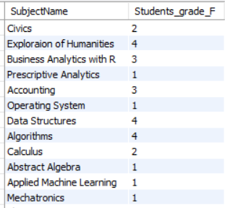

Views :
List of students eligible for dean’s scholarship.
create view Deans_Scholarship as
Select concat(s_fname," ",s_lname) as Student_Name, Dept_Name, Grades from
(Select dept_name, student_ID, marks, Grades, row_number() over (partition by dept_name order by marks desc) as S_Rank from Student_Grades as a
join subjects_t as b on a.subject_ID=b.subject_id
join department_t as c on b.department_ID=c.department_ID) as d
join Students_t as e on d.Student_id=e.Student_id
where S_Rank<=2
order by 3;
Select * from Deans_Scholarship;
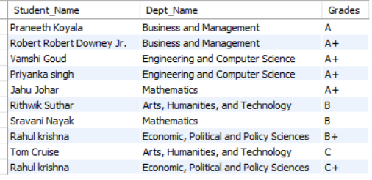
Creating student Transcripts that displays student name, major, subject, marks obtained and the respective grades.
create view Student_Transcript as
Select concat(s_fname," ",s_lname) as Student_Name, Major, SubjectName, marks, Grades from Student_Grades as a
join Students_t as b on a.Student_id=b.Student_id
join subjects_t as c on a.subject_id=c.subject_id
join major_t as d on b.s_major_id=d.major_id
order by 1,2,3;
Select * from Student_Transcript;
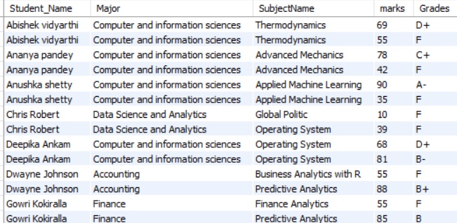

Stored Procedures and Functions
Displays the name of the student who obtained the highest marks in a particular subject along with the subject name.
delimiter //
create procedure topper(
in SubjectID int,
out Subject_Name varchar(255),
out Student varchar(255),
out Top_Marks int)
begin
Select concat(s_fname," ",s_lname) into Student from (Select *, row_number() over(partition by subject_Id order by marks desc) as ranks from students_subjects_t) as a
join subjects_t as b on a.subject_ID=b.subject_id
join Students_t as e on a.Student_id=e.Student_id where ranks=1 and a.Subject_id=SubjectID;
Select marks into Top_Marks from (Select *, row_number() over(partition by subject_Id order by marks desc) as ranks from students_subjects_t) as a
join subjects_t as b on a.subject_ID=b.subject_id
join Students_t as e on a.Student_id=e.Student_id where ranks=1 and a.Subject_id=SubjectID;
Select SubjectName into Subject_Name from (Select *, row_number() over(partition by subject_Id order by marks desc) as ranks from students_subjects_t) as a
join subjects_t as b on a.subject_ID=b.subject_id
join Students_t as e on a.Student_id=e.Student_id where ranks=1 and a.Subject_id=SubjectID;
end //
delimiter ;

call topper(1, @Subject_Name, @Student,@Top_Marks);
Select @Subject_Name, @Student, @Top_Marks;
Function
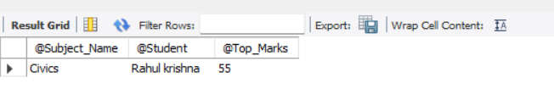
Faculty and subject rating based on student feedback.
Delimiter //
create procedure Combined_Feedback
( in SubjectID int,
in ProfessorID int,
out Combined_Feedback varchar(255))
begin
declare Professor_Feedback float;
declare Subject_Feedback float;
Select avg(rating) into Subject_Feedback from students_subjects_prof_feedback_t where Subject_ID=SubjectID;
Select avg(s_performance_rating) into Professor_Feedback from prof_stud_feedback_t where professor_id=ProfessorID;
set Combined_Feedback=Feedback_Score(Professor_Feedback,Subject_Feedback);
end //
delimiter ;
call Combined_Feedback(16,8,@Combined_Rating);
Select @Combined_Rating;
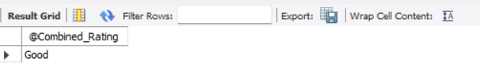

Count of students with less than 75 percent attendance in a particular subject.

delimiter //
create procedure Attendance_Count
(in Subject_ID_I int,
out Subject_I varchar(255),
out l75_Count int)
begin
Select SubjectName into Subject_I from Subjects_t where subject_id=Subject_ID_I;
Select count(student_id) into l75_Count from students_subjects_t as a join subjects_t as b
on a.subject_id=b.subject_id where Attendance_Perc(class_attendence)<0.75 and a.subject_id=Subject_ID_I;
end //
delimiter ;

call Attendance_Count(5,@SubjectName,@Student_Count_l75);
Select @SubjectName,@Student_Count_l75;
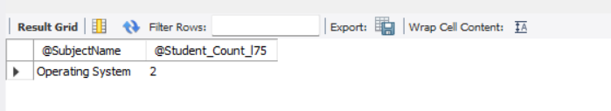

Functions :
Assign letter grade depending on the marks obtained.
DELIMITER //
CREATE FUNCTION Assign_grades(
marks float
)
RETURNS varchar(20)
deterministic
BEGIN
DECLARE Grade varchar(20);
IF ( marks >= 97 and marks <= 100 ) THEN
SET Grade = "A+";
ELSEiF (marks <= 96.99 AND
marks >= 93) THEN
SET Grade = "A";
ELSEiF (marks <= 92.99 AND
marks >= 90) THEN
set Grade = "A-";
ELSEiF (marks <= 89.99 AND
marks >= 87) THEN
set Grade = "B+";
ELSEiF (marks <= 86.99 AND
marks >= 83) THEN
set Grade = "B";
ELSEiF (marks <= 82.99 AND
marks >= 80) THEN
set Grade = "B-";
ELSEiF (marks <= 79.99 AND
marks >= 77) THEN
set Grade = "C+";
ELSEiF (marks <= 76.99 AND
marks >= 73) THEN
set Grade = "C";
ELSEiF (marks <= 72.99 AND
marks >= 70) THEN
set Grade = "C-";
ELSEiF (marks <= 69.99 AND
marks >= 60) THEN
set Grade = "D";
ELSEiF (marks <= 59.99 AND
marks >= 40) THEN
set Grade = "F";
else
set Grade = "W";
END IF;
RETURN (Grade);
end //
DELIMITER ;
Select Assign_grades(87);

Combines Faculty and subject feedback scores and assigns a rating.
Delimiter $$
Create function Feedback_Score
( Professor_Feedback float,
Subject_Feedback float)
returns varchar(255)
deterministic
begin
declare Rating float;
declare Combined_Rating varchar(255);
set Rating=0.5*Professor_Feedback+0.5*Subject_Feedback;
if Rating>=4 then set Combined_Rating="Very Good";
elseif Rating>=3 then set Combined_Rating="Good";
elseif Rating>=2 then set Combined_Rating="Fair";
else set Combined_Rating="Bad";
end if;
return(Combined_Rating);
end $$
delimiter ;

Converts attendance values to percentage.

delimiter //
Create Function Attendance_Perc
(s_class_attendence int)
returns float
deterministic
begin
declare Attendance float;
set Attendance=s_class_attendence/100;
return(Attendance);
end //
delimiter ;

Triggers :
Update Trigger :
It keeps track of the changes made to students_subjects_t table and copies the old values to the Student_Audit table.

#update trigger
create table student_audit(
student_id int,
subject_id int,
marks int,
changedat datetime default null,
action varchar(50) default null
);
create trigger before_student_update
before Update on students_subjects_t
for each row
insert into student_audit
set action='update',
student_id=OLD.student_id,
subject_id=OLD.subject_id,
marks=old.marks,
changedat=NOW();
Select * from students_subjects_t;
update students_subjects_t set marks = 70 where student_id = 12 and subject_id = 9;
Select * from student_audit;
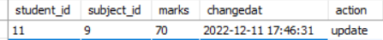

Insert Trigger :
It inserts a new row in the students_grades_t table with the calculated grade every time a row is inserted in the students_subjects_t table.

#insert trigger
create table student_grades_insert(
student_id int,
subject_id int,
marks int,
Grades varchar(2),
changedat datetime default null,
action varchar(50) default null
);

create trigger after_student_grades_insert
after insert on students_subjects_t
for each row
insert into student_grades
set
student_id=new.student_id,
subject_id=new.subject_id,
marks=new.marks,
Grades= Assign_grades(marks)
;
insert into students_subjects_t (student_id,subject_id,marks) values(21,16,55);
select * from student_grades;

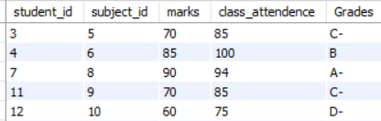

Delete Trigger :
Everytime a student drops a subject, his details are copied into another Students_Drop table.
#delete trigger
create table student_drop(
student_id int,
subject_id int,
marks int,
changedat datetime default null,
action varchar(50) default null
);
create trigger before_student_drop_update
before delete on students_subjects_t
for each row
insert into student_drop
set action='delete',
student_id=OLD.student_id,
subject_id=OLD.subject_id,
marks=old.marks,
changedat=NOW();
Select * from students_subjects_t;
delete from students_subjects_t where student_id = 21 and subject_id = 16;
Select * from student_drop;
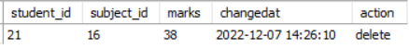

Indexes :
Two indexes were created to deliver quicker access of data. The indexes were applied on key columns often used during data transactions.

CREATE INDEX students_index
ON students_t(student_id);

CREATE INDEX prof_stud_feedback_index
ON prof_stud_feedback_t(student_id, professor_id);

Advantages :
Role Based Access Control : In order to maintain data integrity students would only be provided read-only access. Administrators and Instructors will be able to modify the data.
Reduces the amount of time spent on managing the data.
Uses Indexing to optimize the query search to quickly locate data without having to search every row in a database table every time a database table is accessed.
Ease of use as SQL can be used to access the data thus avoiding complex database navigation.
It reduces data redundancy.

Marketing Strategies:
Our marketing strategy is to develop a universal product which can then be customised to the university with small changes, i.e., displaying the results and reports in the format required by the university. This lowers the pricing while still being able cater to the needs of every university. The next step is developing an online presence by developing a website, creating digital portals, placing ads on search engines and social media platforms as digital marketing has a global reach, can be used to effectively target the universities and be able to communicate with them in real time. We will also be using the traditional marketing strategies like print media and direct sales.

Executive Summary:
The purpose of this project is to develop a progress report management system for universities across the United States of America and be able to provide a unified grading and reporting system. This system would then be accessible to all stakeholders like students, Professors, Staff and parents depending on the type of access given.
Student’s Access: Every student would be able to view their semester wise grades for every subject. They would be able view their scores as soon as tests and assignments are graded. After every test and assignment, they would be able to view if their performance improved on previous tests.
Parent’s Access: Parents would be able to view everything a student does.
Professor’s Access: A professor would be able to view all the student’s grades enrolled in their respective subjects and be able to view the overall class performance. He would also have access to reports showing the students performing below the class average.
He would then be able to make decisions to be able to improve the class performance. The Professor would also be able to insert new data and make changes to the current data.
HOD’s Access: The HOD would have access to everything a professor along with the faculty feedback and course feedback to be able make necessary changes to the learning process.

- The purpose of progress report management system is to give feedback to students so that they can take charge of their learning process.
- Provide information to all the stakeholders supporting the students like teachers, parents and others.
- Identify students in need of more support or practice.
- Track areas of improvement based on course feedback and faculty feedback given by students.
- Provide scholarship eligibility to the students who are consistently performing well.

Conclusion :

The purpose of progress report management system is to give feedback to students so that they can take charge of their learning process.
Provide information to all the stakeholders supporting the students like teachers, parents and others. Identify students in need of more support or practice.
Track areas of improvement based on course feedback and faculty feedback given by students.
Provide scholarship eligibility to the students who are consistently performing well.

